YuvaIntern Ai pioneers internship(Machine Learning Internship) week3
Name : Manasvi Beri task : Unsupervised Learning & Model Evaluation

- Introduction
Machine learning techniques can be broadly divided into supervised and unsupervised learning. Clustering is an unsupervised learning technique that groups similar data points into different clusters without using predefined target labels. Model evaluation, on the other hand, helps measure how effectively a trained machine learning model performs on unseen data.
This task focuses on applying clustering techniques and evaluating a machine learning classification model using the Titanic dataset. Two clustering algorithms, K-Means Clustering and Hierarchical Clustering, were implemented to identify groups of passengers with similar characteristics. Principal Component Analysis (PCA) was also used for dimensionality reduction and visualization of the clusters.
In addition, a Random Forest Classifier was trained to predict passenger survival. Cross-validation, confusion matrix, precision, recall, F1-score, ROC-AUC, and hyperparameter tuning were performed to evaluate and improve the classification model.
The project demonstrates an end -to-end machine learning workflow involving data preprocessing, clustering, dimensionality reduction, classification, model evaluation, and hyperparameter optimization using Python and Scikit-learn.

Objectives
The main objectives of this project are:

  - To understand and implement clustering algorithms.
  - To apply K-Means Clustering to the Titanic dataset.
  - To implement Hierarchical Clustering.
  - To evaluate clustering performance using the Silhouette Score.
  - To understand dimensionality reduction using PCA.
  - To visualize clusters using PCA.

  - To understand cross-validation for machine learning models.
  - To evaluate a classification model using Accuracy, Precision, Recall, and F1-score.
  - To generate and interpret a confusion matrix.
  - To evaluate the model using ROC-AUC.
  - To perform hyperparameter tuning using GridSearchCV.
  - To prepare a comprehensive model evaluation report.

Dataset Description
The Titanic dataset contains information about passengers who travelled on the RMS Titanic. The dataset includes passenger characteristics that can be used to analyze passenger groups and predict survival.
The target variable used for classification is:

Survived

  - 0 – Passenger did not survive
  - 1 – Passenger survived
The features selected for the project include:

Feature Description
Pclass Passenger class
Sex Passenger gender
Age Passenger age
SibSp Number of siblings/spouses aboard Parch Number of parents/children aboard Fare Passenger fare
Embarked Port of embarkation

For clustering, the Survived column was not used because clustering is an unsupervised learning technique.

Tools and Technologies Used
The following tools and libraries were used:

  - Python
  - Google Colab
  - Pandas
  - NumPy
  - Matplotlib
  - Seaborn
  - Scikit-learn

The following Scikit-learn techniques were used:

  - StandardScaler
  - KMeans
  - AgglomerativeClustering
  - PCA
  - RandomForestClassifier
  - Cross-validation
  - GridSearchCV
  - Classification metrics

Data Preprocessing
Before applying machine learning algorithms, the Titanic dataset was cleaned and prepared.

The required columns were selected from the dataset. Missing values in the Age column were replaced using the median age, while missing values in the Fare column were replaced using the median fare.
Missing values in the Embarked column were replaced using the most frequently occurring value.

The categorical variables Sex and Embarked were converted into numerical representations using one-hot encoding.
The preprocessing resulted in a numerical dataset that could be used by the machine learning algorithms.

Feature Scaling
Feature scaling was performed before clustering using StandardScaler. The selected clustering features were:
  - Pclass
  - Age
  - SibSp
  - Parch
  - Fare
These features have different numerical ranges. For example, passenger fare can have much larger values than the number of siblings or parents. Scaling places the features on a comparable scale.
The scaled data was then used as input for K-Means and Hierarchical Clustering.

K-Means Clustering
K-Means is an unsupervised machine learning algorithm that divides data into a predefined number of clusters. Each data point is assigned to the cluster whose centroid is closest to it.
In this project, K-Means clustering was implemented using 3 clusters. The following features were used:
  - Pclass
  - Age
  - SibSp
  - Parch
  - Fare

The K-Means algorithm was initialized with:
Number of clusters = 3
Random state = 42

The resulting cluster labels were assigned to the dataset for further analysis.

Elbow Method
The Elbow Method was used to analyze different values of K from 2 to 10.

The method calculates the inertia for each number of clusters. Inertia represents the sum of squared distances between data points and their assigned cluster centers.
The graph of the number of clusters against inertia was plotted to identify a suitable clustering value.
The resulting Elbow Method graph is included in the project as evidence of the clustering analysis.
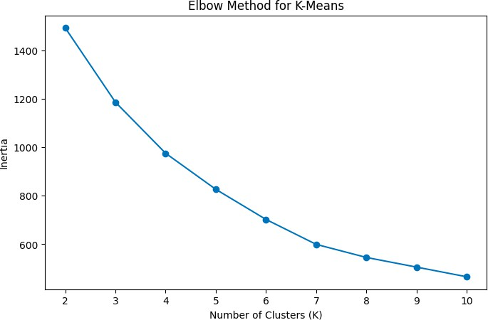

K-Means Silhouette Score
The Silhouette Score was used to evaluate the quality of the K-Means clusters.

The score measures how similar each data point is to its own cluster compared with other clusters. A higher silhouette score generally indicates better-defined clusters.
The Silhouette Score obtained for K-Means was:

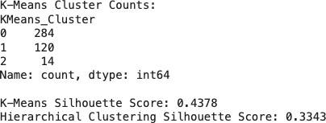

Hierarchical Clustering
Hierarchical Clustering was also implemented to group similar passengers. The AgglomerativeClustering algorithm from Scikit-learn was used with: Number of clusters = 3
The same scaled features used for K-Means were used for Hierarchical Clustering. The resulting clusters were evaluated using the Silhouette Score.
The obtained score was:

Clustering Performance Comparison
The performance of the two clustering algorithms was compared using their Silhouette Scores.
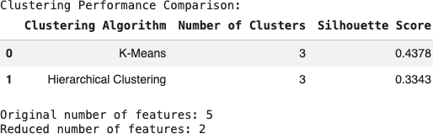

The table provides a direct comparison of the clustering results obtained from the Titanic dataset.

Dimensionality Reduction Using PCA
Principal Component Analysis (PCA) was used as a dimensionality reduction technique. The original clustering dataset contained five features:
  - Pclass
  - Age
  - SibSp
  - Parch
  - Fare

PCA reduced these five dimensions to two principal components.

The two components were used to visualize the clusters in a two-dimensional space.

PCA was useful for presenting the clustering results graphically while retaining important patterns from the original data.

K-Means Cluster Visualization
The K-Means cluster labels were plotted using the two principal components obtained through PCA.
Figure 2: K-Means Clusters using PCA

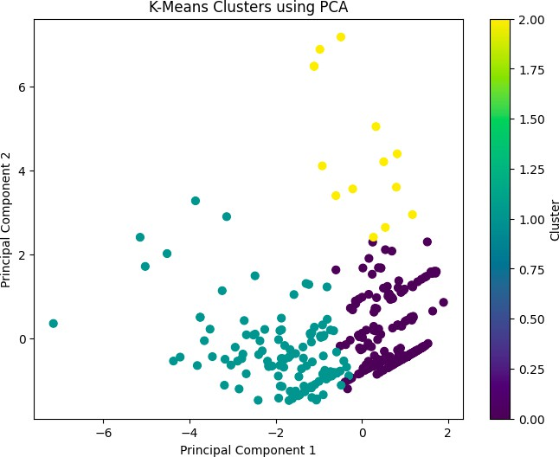

The visualization provides a graphical representation of the three clusters identified by the K-Means algorithm.

Hierarchical Cluster Visualization
The clusters generated by Hierarchical Clustering were also visualized using the PCA-transformed data.
Figure 3: Hierarchical Clusters using PCA
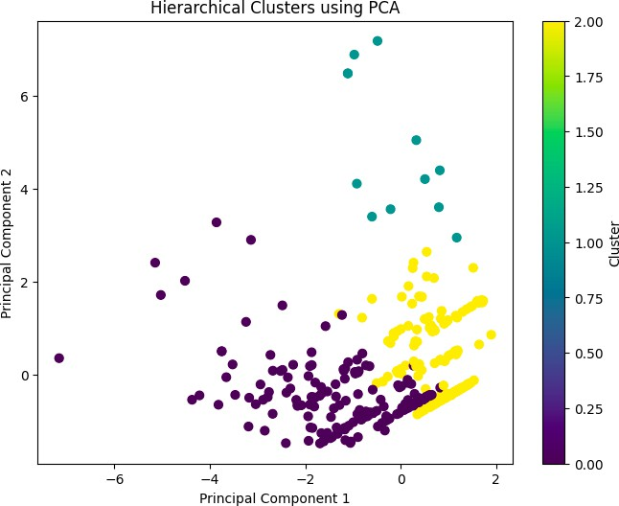
This visualization helps compare the grouping behavior of Hierarchical Clustering with the K-Means results.

Classification Model
In addition to clustering, a supervised classification model was implemented to satisfy the model evaluation objectives.
A Random Forest Classifier was selected for predicting passenger survival.

Random Forest is an ensemble learning algorithm that combines multiple decision trees to make predictions. It can capture relationships between multiple input features and is commonly used for classification tasks.
The target variable was:

Survived

The dataset was divided into:

- 80% training data
- 20% testing data
A random state of 42 and stratified splitting were used.

Cross-Validation
Five-fold cross-validation was performed to evaluate the consistency of the Random Forest model.
The dataset was divided into five parts. The model was trained on four parts and evaluated on the remaining part. This process was repeated five times.
The cross-validation accuracy scores and

The mean five-fold cross-validation accuracy were:
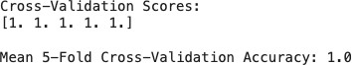

Cross-validation provides a more reliable estimate of model performance than relying on only one train-test split.

Model Evaluation Metrics
The Random Forest model was evaluated using several performance metrics.

Accuracy

Accuracy represents the proportion of predictions that were correctly classified.

Precision

Precision measures how many of the passengers predicted as survivors were actually survivors.

Recall

Recall measures how many of the actual survivors were correctly identified by the model.

F1-Score

F1-score combines precision and recall into a single metric and is useful when both measures are important.

ROC-AUC

ROC-AUC measures the ability of the classifier to distinguish between the two classes.

Classification Results
The Random Forest model produced the following results:
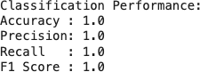

Confusion Matrix
A confusion matrix was generated to understand the classification results in more detail.

The matrix contains:

  - True Positive (TP): Actual survivor correctly predicted as survivor.
  - True Negative (TN): Actual non-survivor correctly predicted as non-survivor.
  - False Positive (FP): Non-survivor incorrectly predicted as survivor.
  - False Negative (FN): Survivor incorrectly predicted as non-survivor.

Figure 4: Confusion Matrix – Random Forest
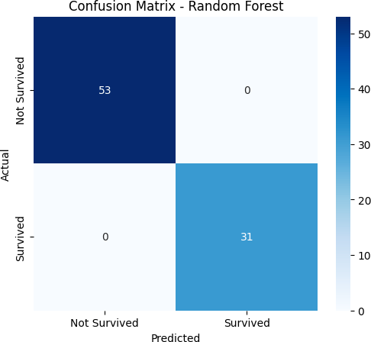

The confusion matrix provides a clear representation of the correct and incorrect predictions made by the classifier.

Classification Report
A classification report was generated using Scikit-learn. The report contains:

  - Precision
  - Recall
  - F1-score
  - Support for both classes:
  - Not Survived
  - Survived

Figure 5: Random Forest Classification Report
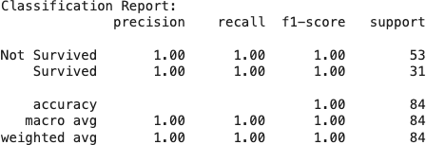

The classification report provides class-wise evaluation of the model.

ROC Curve and ROC-AUC
The model's predicted probabilities were used to calculate the ROC-AUC score and plot the Receiver Operating Characteristic (ROC) curve.

Figure 6: ROC Curve – Random Forest
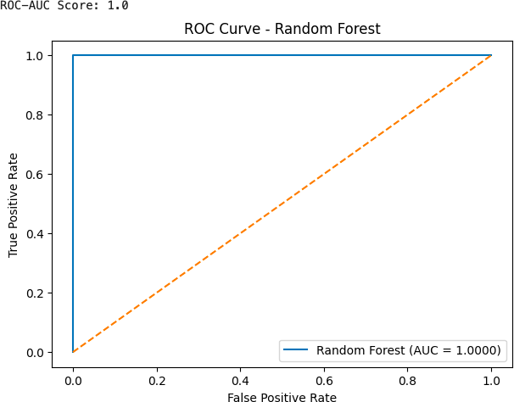

The ROC curve shows the relationship between the True Positive Rate and False Positive Rate at different classification thresholds.
The ROC-AUC score obtained was:

ROC-AUC = 1.0

Hyperparameter Tuning
Hyperparameter tuning was performed using GridSearchCV to identify better-performing Random Forest parameters.
The following parameters were tested:

Parameter Values Tested
n_estimators 50, 100, 200
max_depth None, 5, 10
min_samples_split 2, 5

Five-fold cross-validation was used during the grid search. The best parameters obtained were:
Best Hyperparameters: {'max_depth': None, 'min_samples_split': 2, 'n_estimators': 50}
The best cross-validation accuracy was:

Best Cross-Validation Accuracy: 1.0

Tuned Model Evaluation
After hyperparameter tuning, the best Random Forest model was evaluated on the test dataset. The results were:
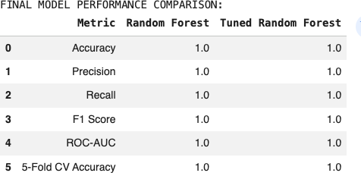

This comparison shows how the model's performance changed after hyperparameter optimization.

Results and Discussion
The project successfully implemented both unsupervised and supervised machine learning techniques using the Titanic dataset.
K-Means and Hierarchical Clustering were applied to passenger characteristics without using the survival target. The Silhouette Score was used to evaluate the quality of the clusters. PCA was then used to reduce the feature dimensions to two components and visualize the resulting clusters.
For supervised learning, a Random Forest Classifier was trained to predict passenger survival. The model was evaluated using accuracy, precision, recall, F1-score, ROC-AUC, confusion matrix, and classification report.
Five-fold cross-validation was used to examine the consistency of the model. GridSearchCV was then applied to tune important Random Forest hyperparameters. The original and tuned models were compared using multiple evaluation metrics.
The results demonstrate how different machine learning techniques can be applied to the same dataset for different purposes, including discovering groups within data and predicting known target classes.

Conclusion
This project provided practical experience with clustering techniques, dimensionality reduction, supervised learning, and model evaluation.
K-Means and Hierarchical Clustering were implemented to group Titanic passengers based on selected characteristics. The Elbow Method and Silhouette Score were used to analyze clustering performance. PCA was applied to reduce the dimensionality of the data and visualize the clusters.
A Random Forest Classifier was also developed to predict passenger survival. The model was evaluated using cross-validation, confusion matrix, precision, recall, F1-score, and ROC-AUC. Hyperparameter tuning using GridSearchCV was performed to search for suitable model parameters.
Overall, this task demonstrates a complete machine learning workflow involving data preprocessing, clustering, dimensionality reduction, classification, evaluation, cross-validation, and hyperparameter tuning using Scikit-learn.

Future Enhancements
The task can be further enhanced by:

  - Testing different numbers of clusters.
  - Applying additional clustering algorithms such as DBSCAN.
  - Performing more extensive feature engineering.
  - Using additional dimensionality reduction techniques.
  - Testing other classification algorithms.
  - Applying more advanced hyperparameter optimization methods.
  - Developing an interactive dashboard for visualizing the clusters and model results.
  - Deploying the trained classification model as a web application.

